UNIVERSITY OF WAH (UOW)

DEPARTMENT OF COMPUTER SCIENCE



COURSE TITLE: INTRO TO INFORMATION SECURITY

COURSE CODE: CS – 251 L

SUBMITTED TO: MS. WASIFA KANWAL

SUBMITTED BY: SAADI SAFDAR

REG #: UW-24-CS-BS-088

BSCS 3RD B

LAB ASSIGNMENT # 9

Task:1
1. Visit CanaryTokens.org.
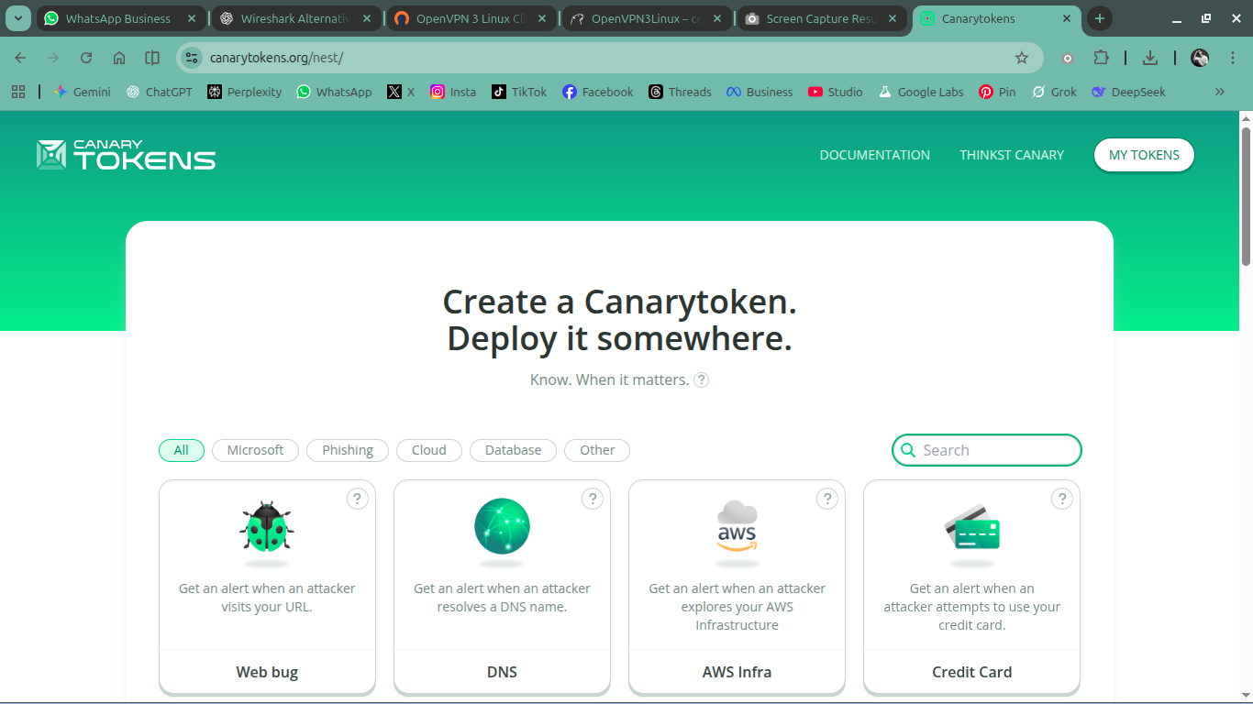
2. Select one token type that was NOT used in the lab (e.g., MS Word Document,URL , or
sensitive Folder).
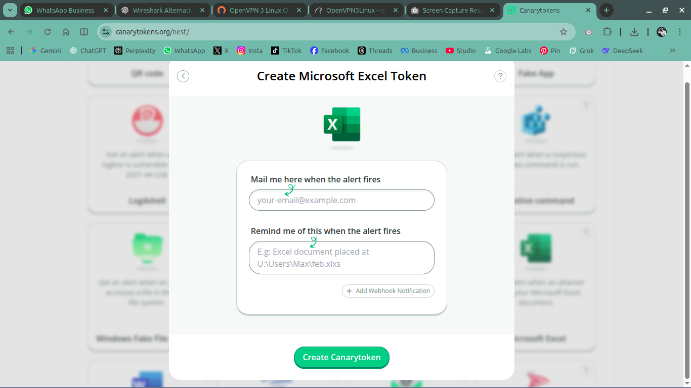

3. Generate the token and place it in your SecureData folder.
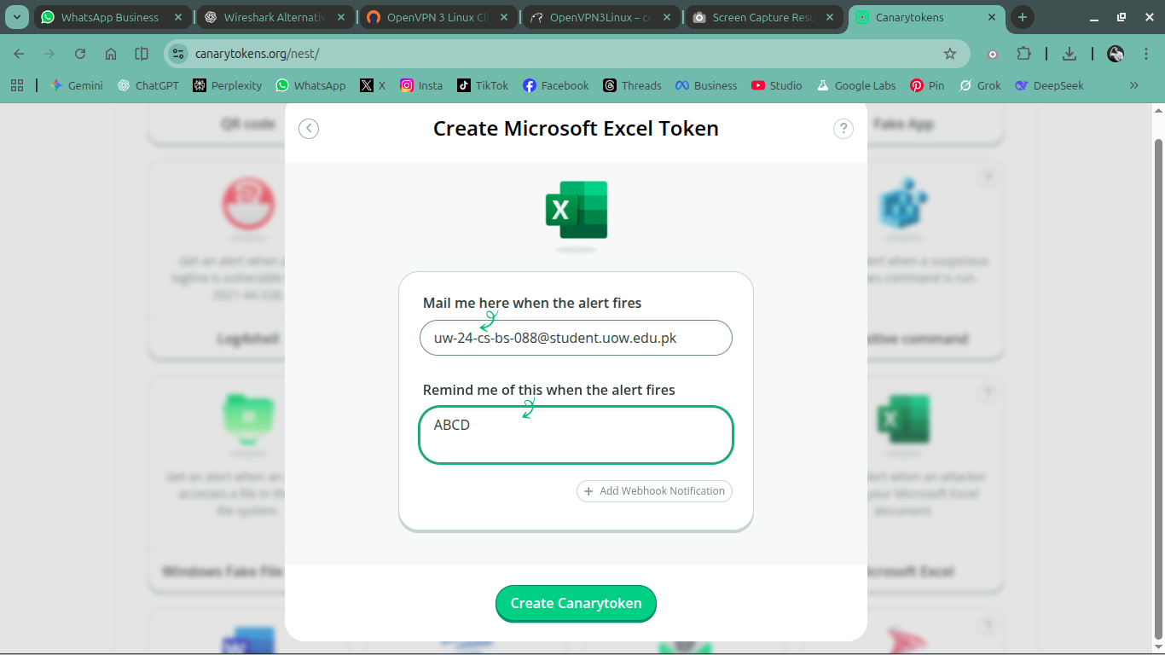
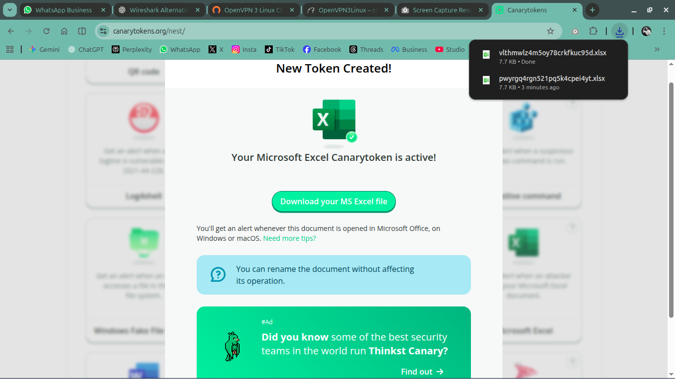

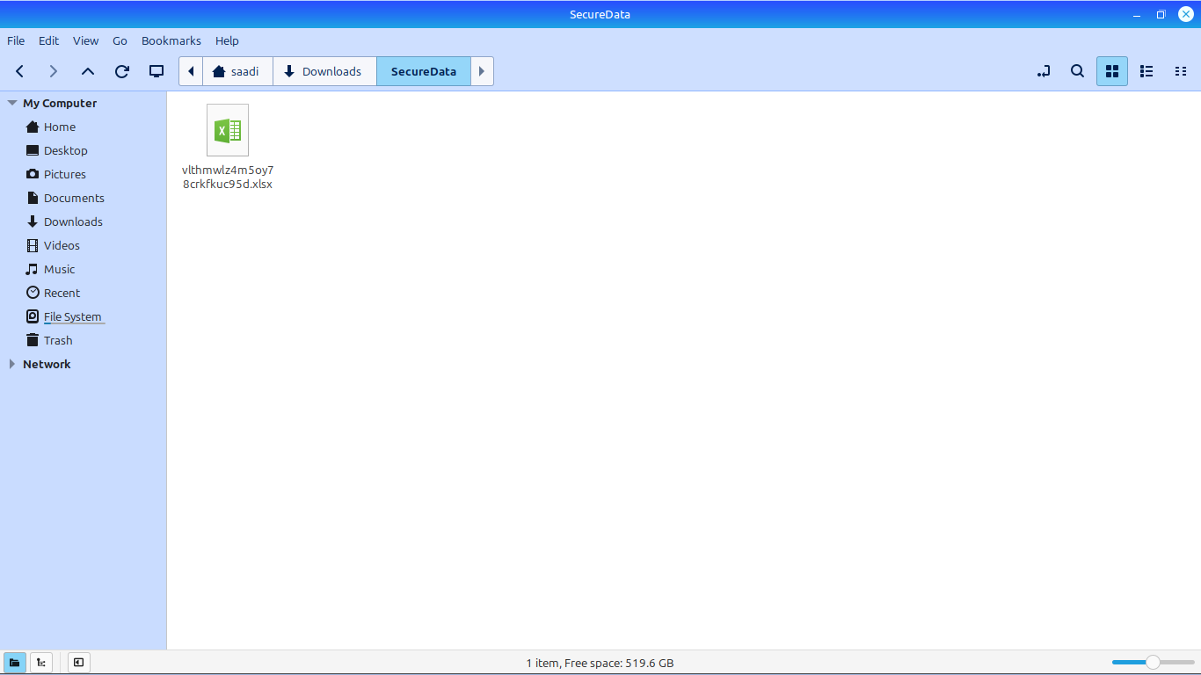
4. Trigger the token
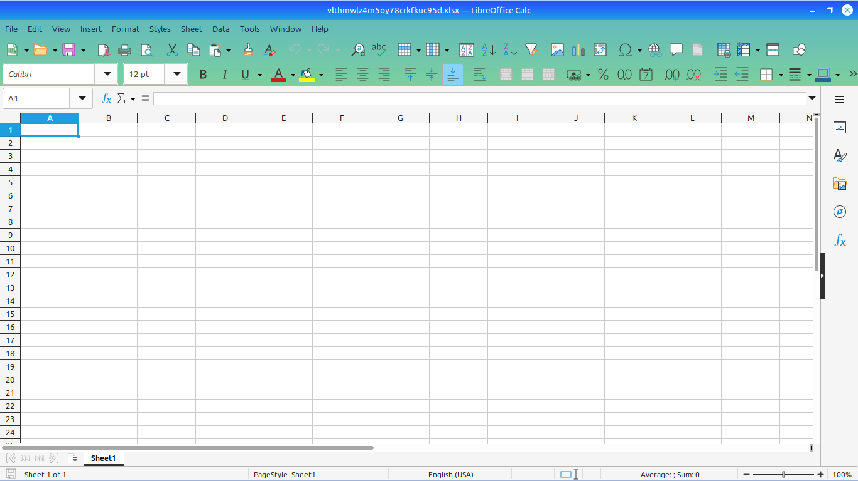

5. Check your email for the alert.

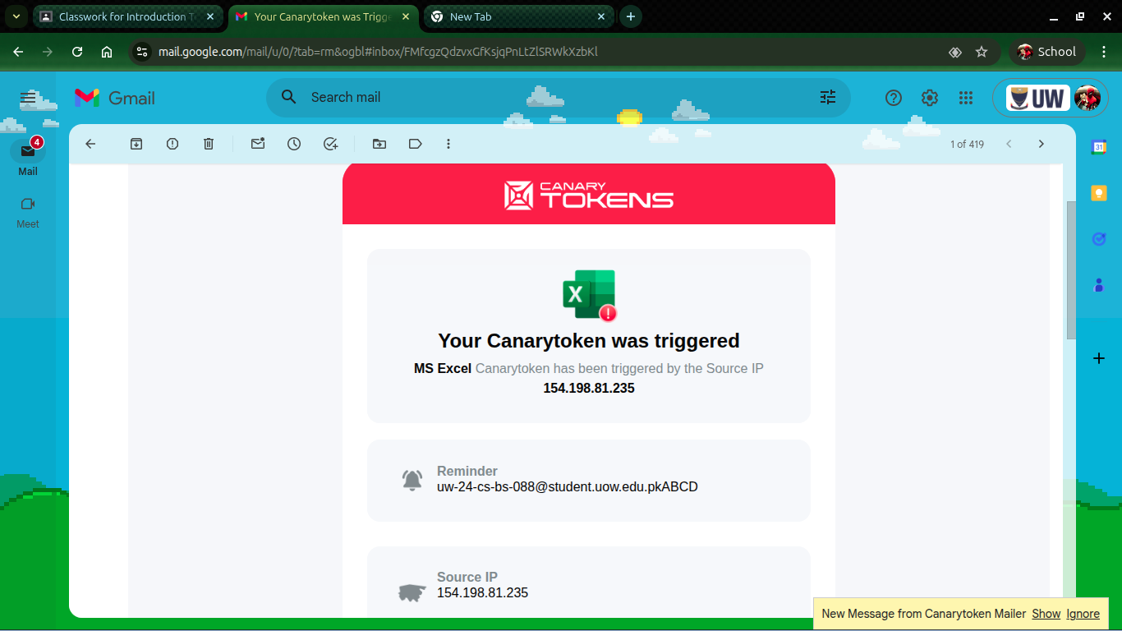
The token was generated on CanaryTokens.org and saved in the SecureData folder as required.​​
When the token file/link was opened, it triggered a request to CanaryTokens and an alert email was received, confirming that access to the token was detected.​​
This shows how CanaryTokens function as a simple honeypot: any unauthorized access to the protected file or URL immediately sends an alert to the owner, helping to detect intruders or suspicious activity on sensitive data.​

Task 2:
Block DNS Traffic to Prevent Malware Communication
1. Create a New Outbound Rule in Windows Defender Firewall.
2. Select Port and choose UDP.
3. Enter Specific Remote Port: 53.
4. Action: Block the connection.
5. Name the rule: Anti_Malware_DNS_Block.

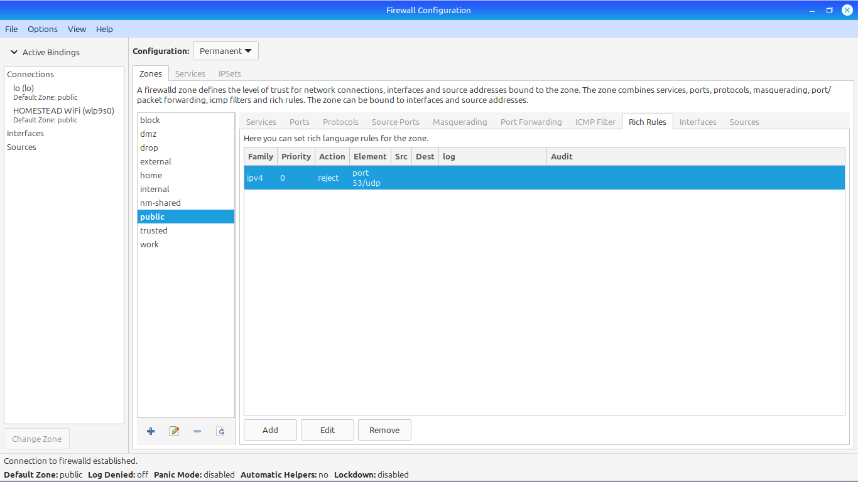

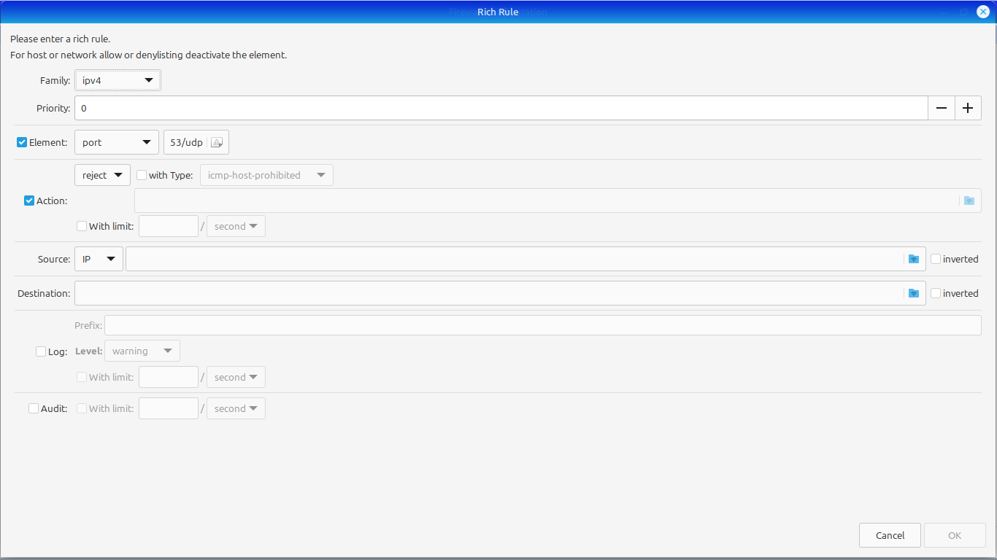

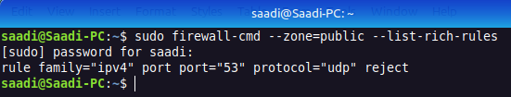

The lab asks for an outbound rule named Anti_Malware_DNS_Block in Windows Defender Firewall, but this system is running Linux Mint Cinnamon, which uses firewalld instead of Windows Defender.​
In the firewalld GUI, a rich rule was added in the public zone to drop UDP traffic on port 53, which is the DNS port: rule family="ipv4" port port="53" protocol="udp" drop.​
Blocking outbound DNS in this way provides the same security effect as the Windows rule: malware on the host cannot resolve domain names of command-and-control servers, making it much harder for it to communicate or exfiltrate data.​

Task:3
1. Start a Wireshark capture on your active network interface (Wi-Fi or Ethernet).
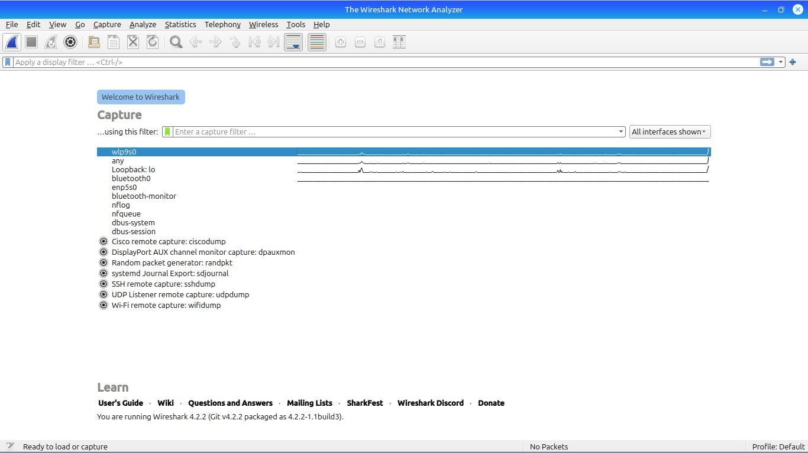

2. Open your browser and visit a website you have never visited before.

3. Stop the capture after the page loads.
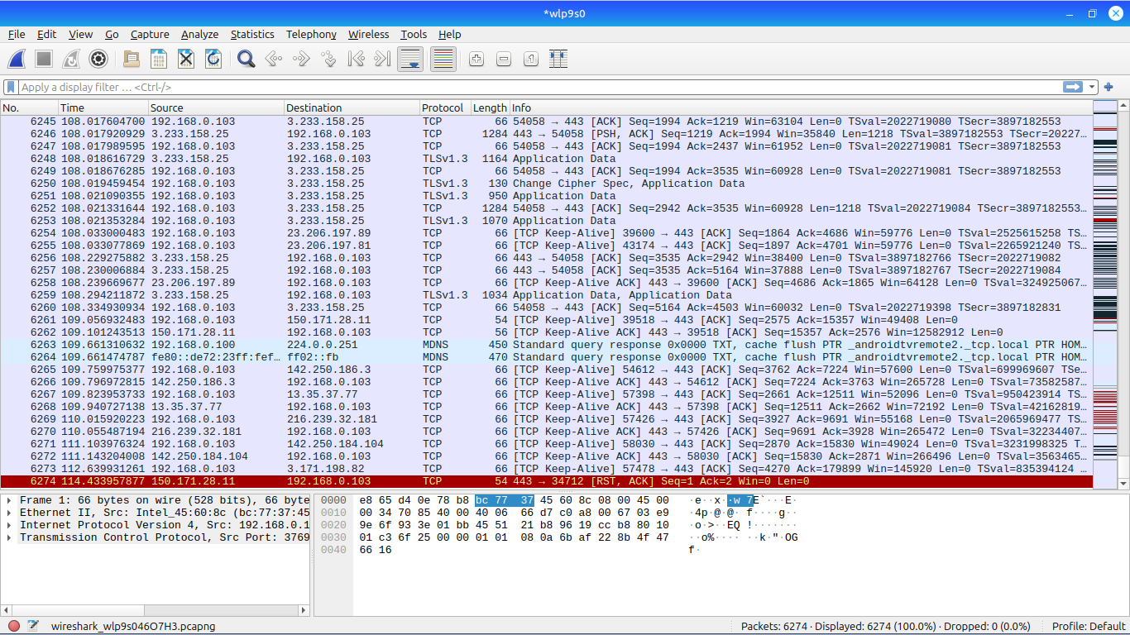

4. Filter for DNS: Use the display filter dns. Find the packet that resolved the website name
to an IP address.

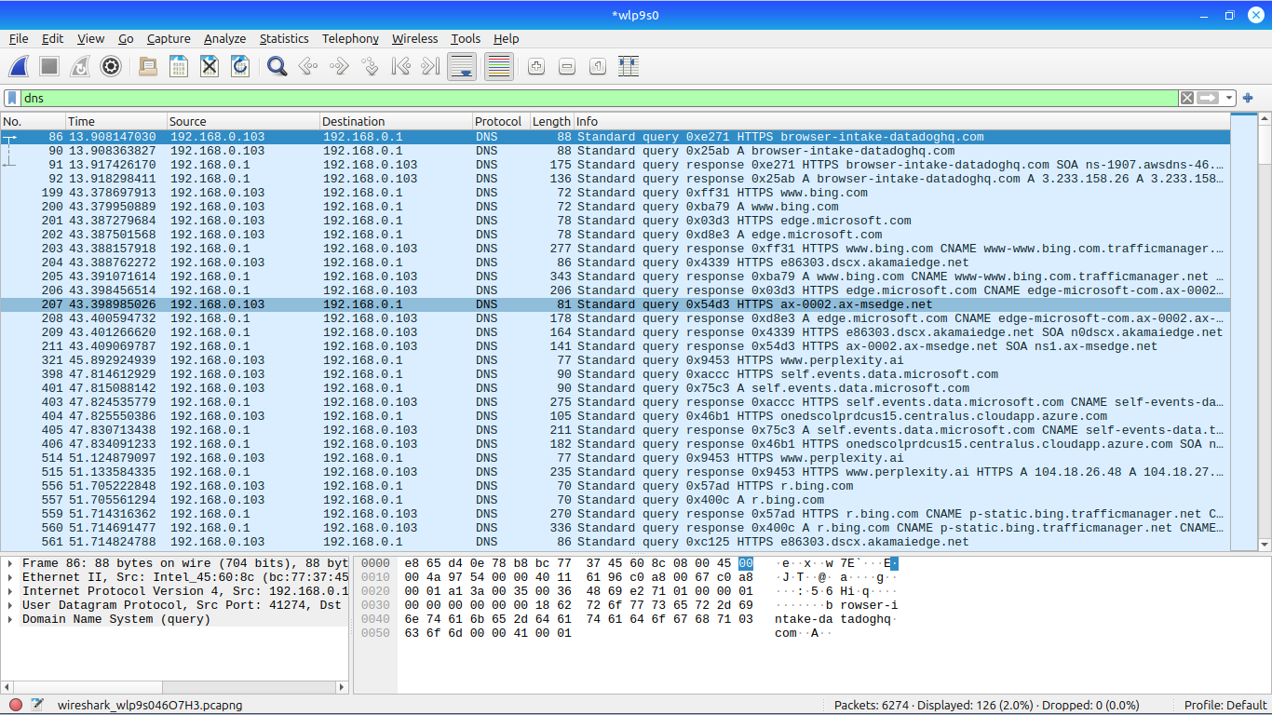

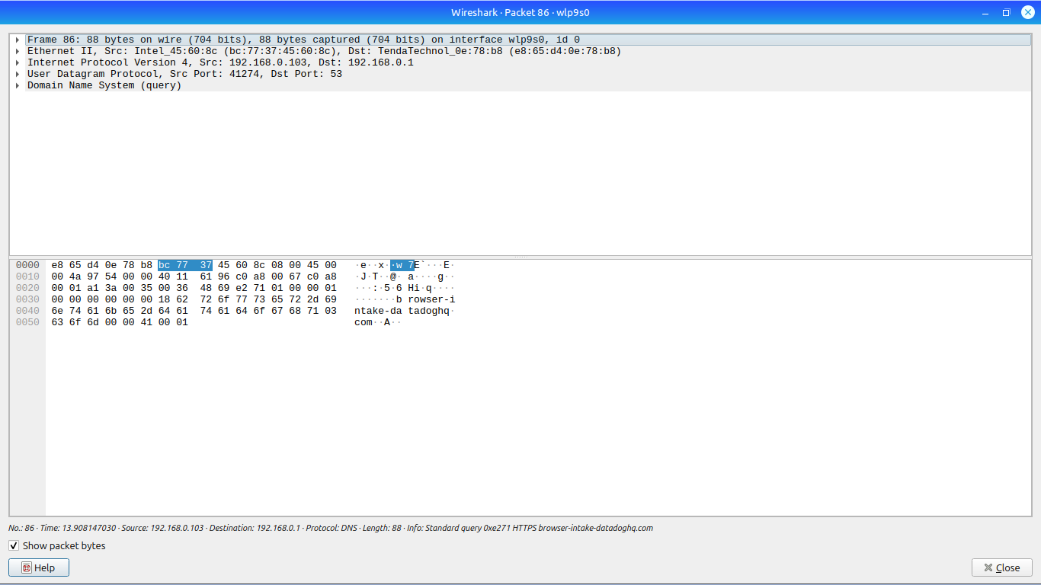
5. Filter for TCP Handshake: Use the display filter tcp.flags.syn == 1. This shows the
initial knocking on a server’s door.

